**Analytic Functions - Basic**

Task 01. Create Ad Hoc SQL FIRST_VALUE, LAST_VALUE

Task that was solved by using functions FIRST_VALUE, LAST_VALUE is searching first and last value of budget deficit for 5-year range for every country.

Script is in attached file First,last_values_test.sql. Result of script running is presented below.

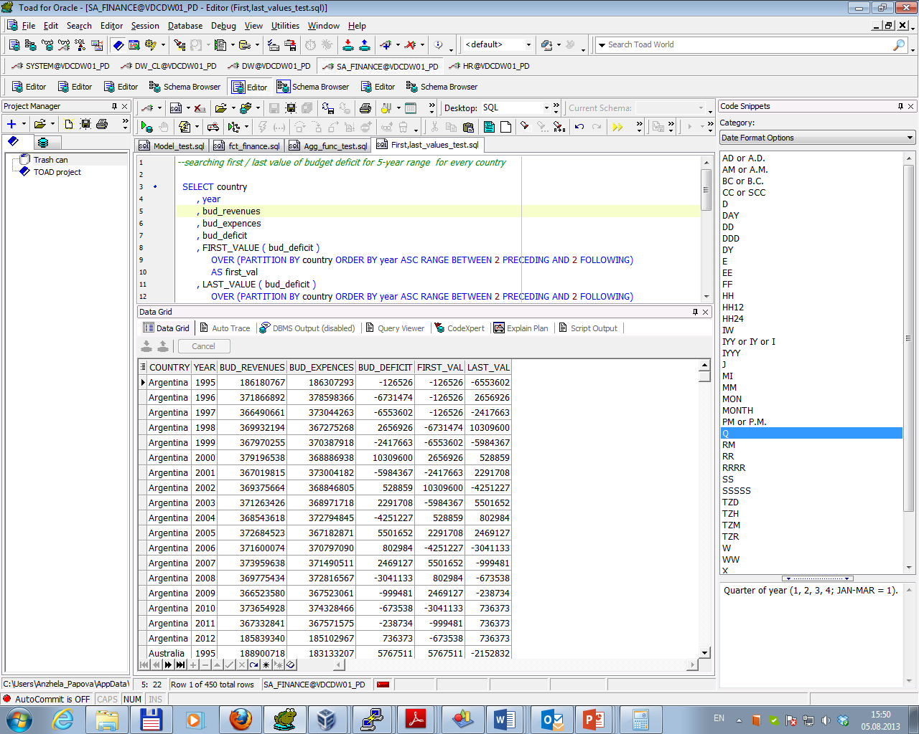

Task 02. Create Ad Hoc SQL RANK, DENSE_RANK, ROWNUM

Task that was solved by using rank functions is to search countries, their year funding with density in total funding which meet the next conditions:

* year funding is in top 10 of year funding;
* year funding is in top 3 of country funding.

List of country should be organized by total funding rank (descending order).

Script is in attached file Rank_test.sql. Result of script running is presented below.

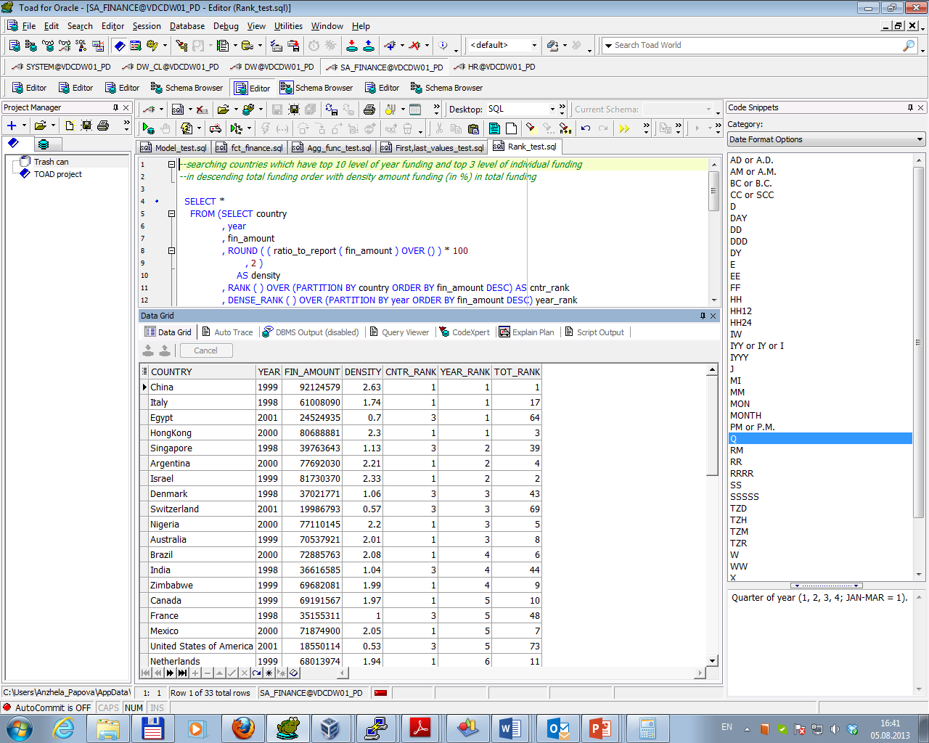

Task 03. Create Ad Hoc SQL AGGREGATE FUNCS

Tasks that were solved by using aggregate functions are:

* Calculating running total GDP value of each country quarterly from year beginning (function sum() was used);
* Searching maximal /minimal GDP level within country (functions max() and min() were used);
* Searching average GDP of all countries within year (function avg() was used).

Script is in attached file Agg_func_test.sql. Result of script running is presented below.

